Classes “Firm”, “Staff”, “StaffMember”, “Volunteer”, “Employee”, “Executive”, and “Hourly “are from Listings 7.16 - 7.22 in the text. The program illustrates inheritance and polymorphism. In this exercise you will add one more employee type to the class hierarchy; see the figure below for the inheritance hierarchy.
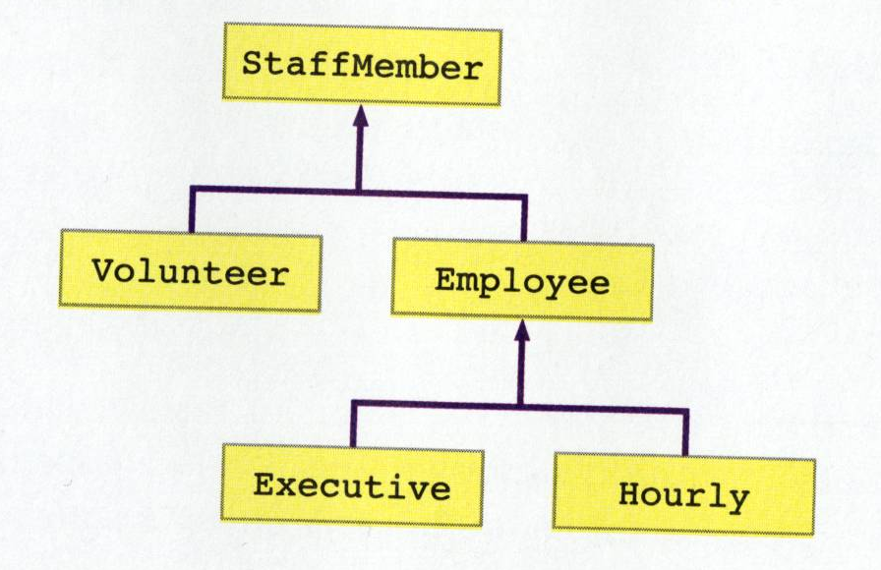

The new employee class will be one that is an hourly employee and also earns a commission on sales. Hence the class, which we'll name Commission, will be derived from the Hourly class.

Write a class named Commission with the following features:

- It inherits from the Hourly class.
- It has two instance variables that it will manage: (1) the total sales the employee has made (type double) and (2) the commission rate for the employee (also a double). The commission rate will represent the percent commission that the employee earns on sales. For example, 0.2 would mean the employee earns 20% commission on sales.
- The constructor should take 6 parameters: the first 5 are the same as for the Hourly parent (name, address, phone number, social security number, hourly pay rate) and the 6th is the commission rate. Be sure to get the parameters to the appropriate instance variables.
- One new method is needed (in addition to the inherited methods): addSales. The method should receive a double parameter representing new sales, and add that to the total sales instance variable. The method doesn’t need to return anything unless you want to return the new total sales.
- Override the getPay method inherited from Hourly. The pay for a Commission should be the pay that an Hourly receives, plus the commission based on the sales (commission rate times sales). As the getPay method finishes calculating the pay for a Commission, it should reset the total sales back to zero.
- The toString method inherited from the parent should be overridden. It should produce what the parent’s toString produces, with additional information about the total sales concatenated onto the end of that. Please format it in a nice, human readable way (including a label).

To test your class, update Staff.java as follows:

- Increase the size of the array to 8.
- Add two commissioned employees to the staffList -- make up your own names, addresses, phone numbers and social security numbers. Have one of the employees earn $6.25 per hour and 20% commission and the other one earn $9.75 per hour and 15% commission.
- For the first additional employee you added, set the hours worked to 35 and the total sales to $400; for the second, set the hours to 40 and the sales to $950.

Run the program. Make sure it is working properly.

